Getting Started in PS

First Timers

Getting started the first time

How to jump onto a project

How to use eclipse/git on an ongoing basis:

How to upgrade ebx

Sharing data

Setup PS Workspace in your local environment

Setup ps-mdm project in your local environment

Setup Workspace for a new PS engagement

Setting up customer-purchased add-ons

Eclipse Preference Settings

# First Timers

## Getting started the first time

1. Download latest eclipse ([Oxygen](http://www.eclipse.org/downloads/packages/release/Oxygen/1A), as of 07/01/17)
2. get a recent JDK for java, too, like 1.8 (prefer SDK/JDK over jre for development)

## How to jump onto a project

1. Request GIT access
   1. watch the appropriate repos for changes/notifications
2. Get MDM workspace (e.g. [Viacomm](https://drive.google.com/a/orchestranetworks.com/file/d/0B9cOuCsmU3hGV0t4R1JSQWFNbms/view?usp=sharing))
3. Launch eclipse in the exploded workspace
   1. Make sure you are using the right Java and compilation settings
   2. Java 1.8 jdk with 1.8 compiler and compliance settings
   3. reimport the ps preferences (epf) (File>Import>General>Preferences)
   4. reimport the java formatter (Windows>Preferences>Java>Code Style>Formatter)
4. Go to the Git perspective to obtain the Git resources to add to the workspace
   1. Clone git repo
   2. enter URL of Git repo, e.g. <https://bitbucket.org/orchestranetworks/viacom-mdm>
   3. enter credentials (or even better, set up SSH)
   4. point clone to your workspace
5. Explode the repository zip in the customer project’s repository folder into EBX-Home/ebxRepository/h2
6. Clean all projects and launch the start EBX server launch configuration
   1. each customer project generally uses its own port, so to explore Viacom, for instance, use localhost:8484/ebx
   2. this is declared in EBX Server/conf/server.xml -- a Connector/port

## How to use SSH keys with BitBucket

If this is your first time, the easiest way to do this is in eclipse.

1. Window>Preferences>General>Network Connections>SSH2
2. If you don’t already have a rsa key, you can generate one on the Key Management tab
3. Copy the public key to BitBucket under Profile>Settings>Security>SSH Keys

Using SSH keys makes it easier to share a workspace with a colleague as none of your credentials are in the workspace/git clone.

## How to use eclipse/git on an ongoing basis:

1. when you are ready to commit, use synchronize perspective
2. always good to rebase first (how)?
   1. hammer: save all your local changes to somewhere else
   2. Team>Replace with… and choose a particular branch/version that is the git branch you are using.
   3. Synchronize perspective, pull.
   4. Then you can re-apply your changes…

In case of Conflicts:

* Open the merge view, move changes from right to left
* Mark as Merged
* Commit that 1 file to local repo. (do not push)
* Pull on customer module/project
* Now all files will show as red marks (but all the files would have got successfully pulled, check this in Project Explorer)
* Right click on project and do a Commit to local repo (all the files will appear on the list except for the 1 file that was earlier committed)
* This should sync your local repo and list all the files with a grey mark
* Now do a Push, this should push all your changes to the remote

For XSDs, generally after the commit to the local repo, there are ‘====’ merge conflict marks in the file that need to be manually fixed before you can commit and push. As a rule, you should be sure to carefully, manually fix the XSD, reimport into EBX and republish to make sure there are not errors.

## How to upgrade ebx

Before copying the jars and wars, clean out the EBXServer webapp folder and work/Catalina/localhost subdirs. And before starting the server, do a workspace clean.

1. When a new release of EBX is available, go to orchestranetworks/support, log in with the support userid, and replace the following in the EBX Server project:
   1. webapps/ebx-dataservices.war
   2. webapps/ebx-dma.war
   3. webapps/ebx-manager.war
   4. webapps/ebx-root-1.0.war
   5. webapps/ebx.war
   6. shared/lib/ebx.jar
2. Also, if new add-ons are available, replace appropriate wars and jar

## Sharing data

Collaborators can share reference/master data in a number of ways:

* table export/import or data exchange
  + export table as csv, put in project/artifacts/data folder in SCM system
  + use dataExchange export as excel and put in data folder
  + use data space archive export and share in data folder
* import tables from table files (dataExchange xlsx files or actions>Import from csv or xml -- prefer csv as xml is not tolerant of data model changes)
* copy .ebx data space archives to EBX Home/ebxRepository/archives and use DataSpace>Archive>Import
* zip repository -- not recommended to check in a substantial repo zip into project, but share on gdrive if necessary. Unzip into EBX Home/ebxRepository/h2

# Setup reference PS Workspace in your local environment

1. Create a workspace directory “PSWorkspace” and launch Eclipse pointing to this workspace
2. Clone the GIT repository for PS Workspace using the URL: <https://bitbucket.org/orchestranetworks/psworkspace>
   1. If you are using the eclipse git plugin to pull the project, you can’t pull it into a non-empty folder, so you should pull to a sibling directory and then, when the pull is complete, you can use eclipse to switch workspaces to the other one

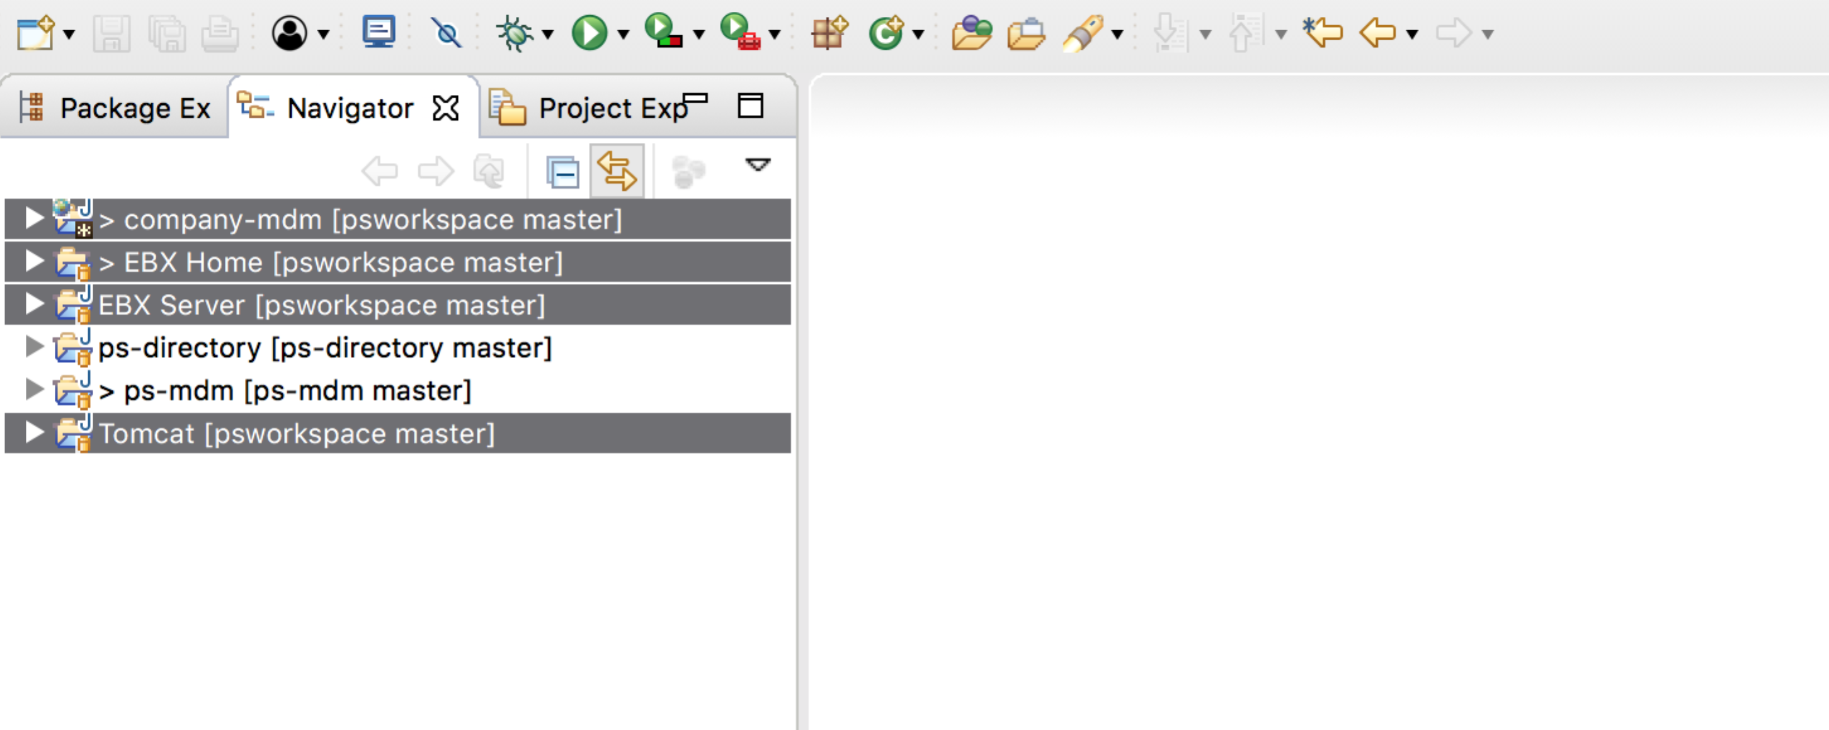

## Setup ps-mdm project in your local environment

1. Launch Eclipse in the PSWorkspace (that was setup earlier)
2. Import ps-mdm into your project
   1. If you have ps-mdm cloned already, use File>Import>General>Existing Projects into Workspace to pull it in
   2. Otherwise, clone the GIT repository for ps-mdm using the URL: <https://bitbucket.org/orchestranetworks/ps-mdm>
   3. Once this has compiled, you can export ps-mdm as a jar file as follows
      1. Right click on ps-mdm project
      2. Export>Java>JAR
      3. Select only the source ‘src’ folder under ps-mdm to be included
      4. Set the destination of the jar to be EBXServer/shared/lib/ebx-pslib.jar

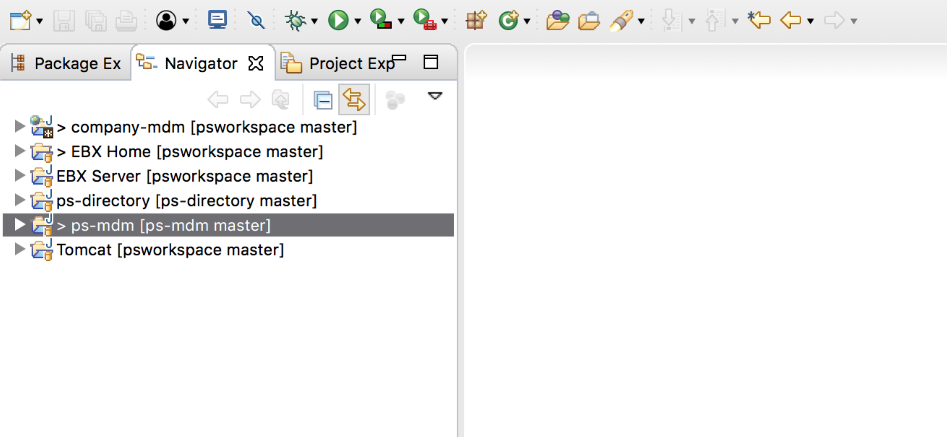

## Setup ps-directory project in your local environment

1. Launch Eclipse in the PSWorkspace (that was setup earlier)
2. Import ps-directory into your project
   1. If you have ps-directory cloned already, use File>Import>General>Existing Projects into Workspace to pull it in
   2. Otherwise, clone the GIT repository for ps-mdm using the URL: <https://bitbucket.org/orchestranetworks/ps-directory>
   3. Once this has compiled, you can export ps-directory as a jar file as follows
      1. Right click on ps-directory project
      2. Export>Java>JAR
      3. Select only the source ‘src’ folder under ps-directory to be included

Add this jar to the classpath of the application server that uses custom directory.

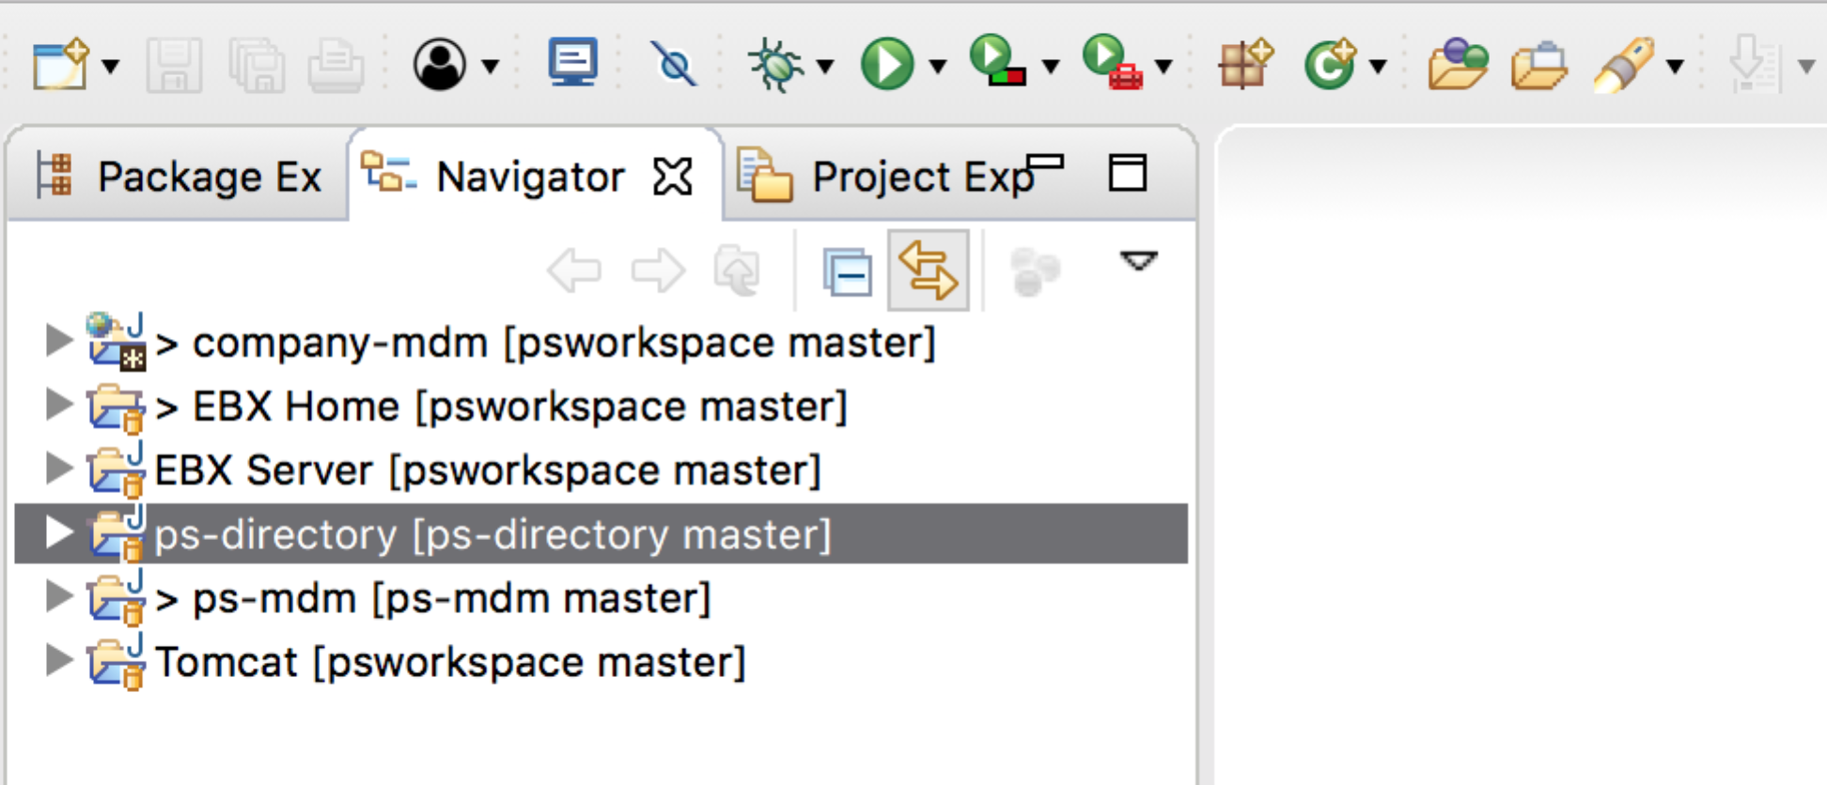

## Setup a local workspace for a new PS engagement

1. Make a copy of the PS Workspace and rename it to “CompanyWorkspace” (eg: PaneraWorkspace)
   1. Remove the .git folder from the workspace folder
2. Launch Eclipse pointing to CompanyWorkspace
3. Make the following changes in “EBX Home” project
   1. Update the EBX license (ebx.license property) in ebx.properties file
4. Make the following changes in “EBX Server” project
   1. Open “Start EBX.launch” file under EBX Server/ant/launches
      1. Search for “company-mdm” and replace it with “mycompany-mdm” (eg: panera-mdm) [verify: there’ll be 3 occurrences of company-mdm to be replaced]
   2. Do the same for “Start EBX - IgnoreCompletionCriteria.launch” under EBX Server>ant>launches
   3. Do the same for “Stop EBX.launch” under EBX Server>ant>launches
   4. Open “server.xml” file under EBX Server/conf
      1. Update the Server port for SHUTDOWN. Give it a port that is not used by any of your other projects.  
         <Server port="9005" shutdown="SHUTDOWN">
      2. Update the Connector port (which would be used to launch ebx http://localhost:8484/ebx). Give it a port that is not used by any of your other projects.  
         <Connector port="9090" protocol="HTTP/1.1"

connectionTimeout="20000"

redirectPort="8443" useBodyEncodingForURI="true" />

* + 1. Add the Context path of “mycompany-mdm” to be deployed along with ebx.war. Replace “company-mdm” with “mycompany-mdm”  
       <Context path="/company-mdm" docBase="../../company-mdm/WebContent"/>

1. Make the following changes to the “company-mdm” project.
   1. In eclipse, right click on the ‘company-mdm’ project, Refactor>Rename to ‘mycompany-mdm’
   2. Also refactor rename the company-mdm folder under webapps
   3. Search>File>File Search to find all occurrences of ‘company-mdm’, using file name patterns ‘*’
   4. In the Search results pane, got to each file and replace all ‘company-mdm’ with ‘mycompany-mdm’, results should include
      1. .classpath
      2. The model xsd files
      3. web.xml
      4. module.xml
      5. dev-artifacts.properties
   5. Rename “DomainDataModel.xsd” to your domain data model   
      Example: “EntitlementDataModel.xsd”  
      Similarly, rename “DomainReferenceDataModel.xsd” and “DomainTypesDataModel.xsd” per your domain.
2. Start EBX using the Debug/Run Configuration
   1. First may need to import the launch configurations using File>Import>Run/Debug>Launch Configurations (from EBX Server/ant/launches)  
      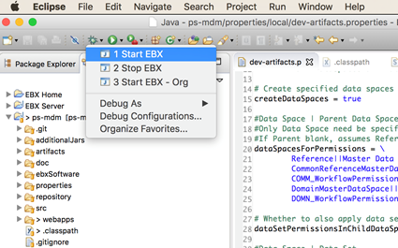
3. Login to EBX http://localhost:9090/ebx
4. Create Data Models and Import/publish the respective xsd files. Refer the below screenshot for data model naming convention  
   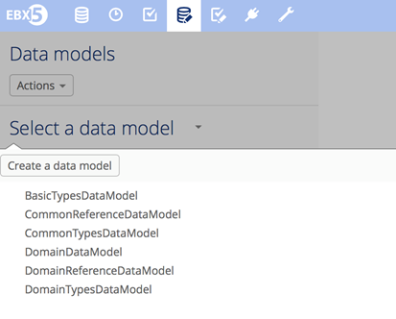
5. Go to eclipse and open “properties/local/dev-artifacts.properties” and update the dataspace and dataset names per the ones that were just created. This will allow you to avoid having to manually create data spaces and data sets.  
   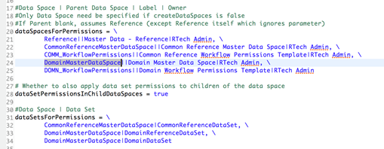
6. Go to the Master Data - Reference data space, use Actions>Admin>Import Dev Artifacts to create initial data spaces and data sets.

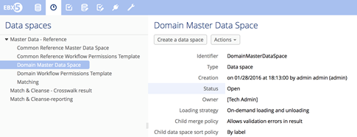

## Setting up customer-purchased add-ons

|  |  |
| --- | --- |
| **Add-on** | **war-file** |
| Activity Monitoring | ebx-addon-mtrn.war |
| Data Exchange | ebx-addon-adix.war |
| Digital Asset Manager | ebx-addon-dama.war |
| Hyperion | ebx-addon-hmfh.war |
| Graph View | ebx-addon-gram.war |
| IGov | ebx-addon-igov.war |
| Information Search | ebx-addon-tese.war |
| Insight | ebx-addon-dqid.war |
| Match & Cleanse | ebx-addon-daqa.war |
| Rules Portfolio | ebx-addon-rpfl.war |

## 

## 

## Eclipse Preference Settings

1. Import the ps formatter under Window>Preferences>Java>Code Style>Formatter  
   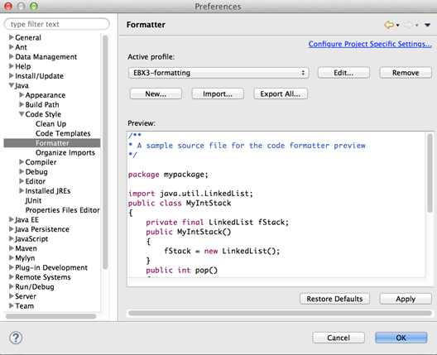
2. Set the “Organize Imports” setting under Window>Preferences>Java>Code Style>Organize Imports  
   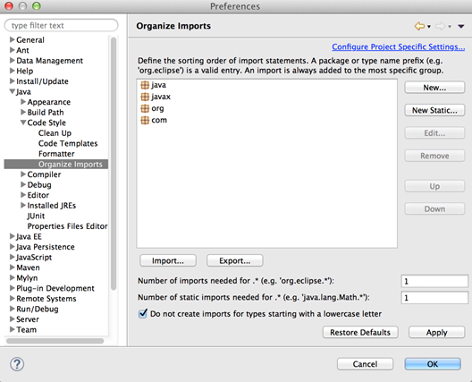
3. Set the “Save Actions” setting under Window>Preferences>Java>Editor>Save Actions  
   